**Research Program Overview**

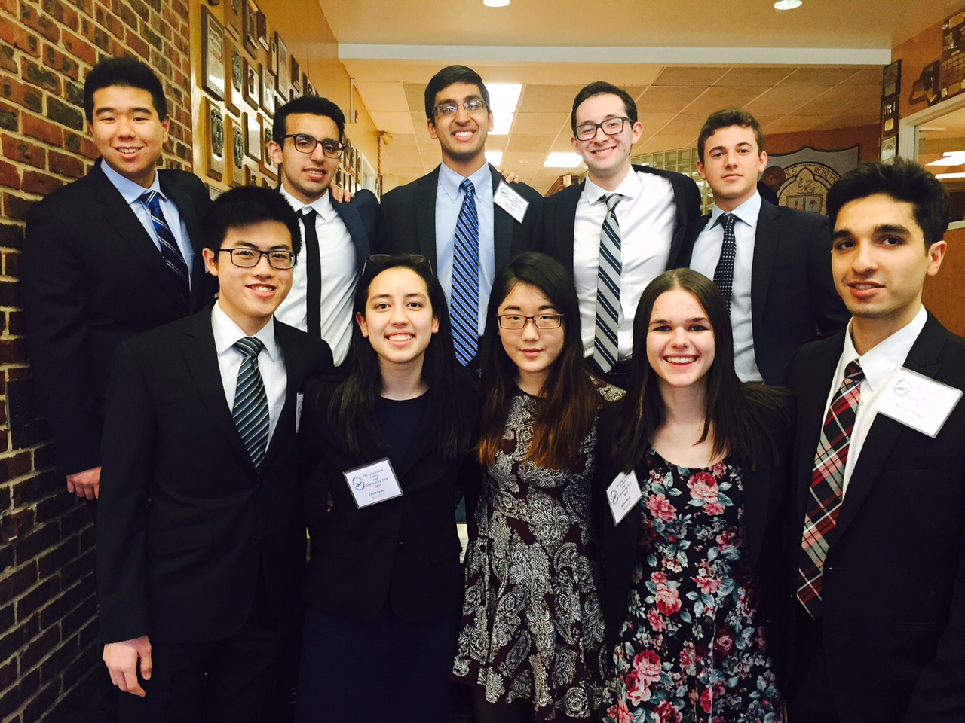

RHS Entrants in 2017 Long Island Science and Engineering Fair

***“****When interviewing at Goldman Sachs for an investment management internship, I wasn't asked one question about finance but I think I presented my whole research presentation 15 times....All of my interviewers were so impressed by a high school student's ability to conduct research and analyze data (and I was impressed by how much of it I could still present by heart). I even got the job! I was surprised to see how much research still plays a role in my life and wanted to say again how appreciative I am for having learned so many valuable skills throughout the research process.****”***

--Chelsea Jurman, RHS ’09

Roslyn High School’s Research Program provides the rare opportunity for students to design and conduct their own high-level projects in virtually any area of science or mathematics.

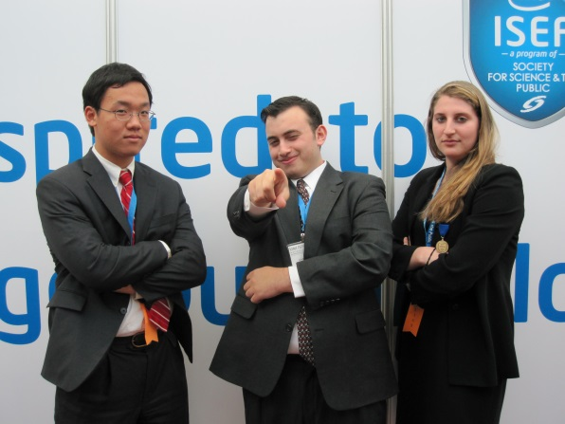**RESEARCH AREAS**

Many of our students have done worked in various behavioral science disciplines such as psychology, epidemiology, behavioral medicine, political science, and economics. This work can be done at school or in a lab (e.g., university, medical practice).

RHS at International Science and Engineering Fair

Example of student project titles include:

* The Relationship between Psychosocial Factors in the Patient-Oncologist Relationship and Quality of Care: A Study of Breast Cancer Patients
* The Effect of Stereotype Threat on Girls' Performance on a Math Test
* The Relationship between School Starting Time, Student Sleep, Academic Performance and Mood

Other students work in theoretical math to develop and prove their own theorems. Projects include:

* Classifying Generic Smooth Curves in the Projective Plane Related to Algebraic Curves of Degree 5
* A Computer-Based Solution Generator for Integral Solutions to Pell's/Fermat's Second-Degree Diophantine Equation
* Periodic Binary Sequences

Students also pursue opportunities in local (and far off) laboratories where they carry out research in fields including environmental science, physics, and genetics. Project titles include:

* An Innovative Approach to Recover Nitrogen from Wastewater Using Nanostructured Cellulose Sulfate
* Designing a Universal Liquid 3-Dimensional Printer Utilizing a Novel Liquid Transport System
* Targeted Delivery of Toxic Nanoparticles: A Novel Innovation for Cancer Treatment

**RESEARCH SEQUENCE**

**Year I:**

Semester 1: Introduction to Research

* 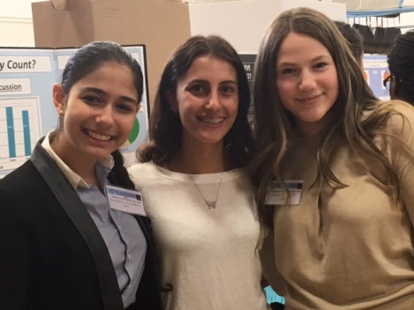One semester
* Overview of basic research design and statistics
* Opportunity to design and carry out a group project

Semester 2: Research Essentials

* One semester
* Builds students’ ability to read and synthesize complex texts
* Trains students to present research effectively via written papers and oral presentations

**9th Grade Team at Ecybermission National Finals**

**Year II and/or III:** Research Seminar and Advanced Research Seminar

* Alternate-day, small-group classes
* Project-focused
* Builds on curriculum learned in introductory class

**Year III and/or IV**: Independent Study Research

* 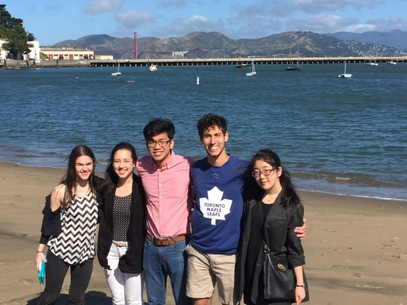Students identify an area of interest and are aided in finding outside experts and/or labs in which they can work independently on a project of their own design
* Students meet weekly, one-on-one, with the Research Coordinator during free periods or a lunch period, much as a college student works with a professor on a thesis
* Students may pursue opportunities to publish or present at professional conferences
* One-half credit is earned for each semester of independent study research

**Research goes west: Presenters at Stanford**

**Undergraduate Psychology Conference**

***Please contact Dr. Allyson Weseley at*** [***aweseley@roslynschools.org***](mailto:aweseley@roslynschools.org) ***or***

***(516) 801-5170 if you have any questions.***